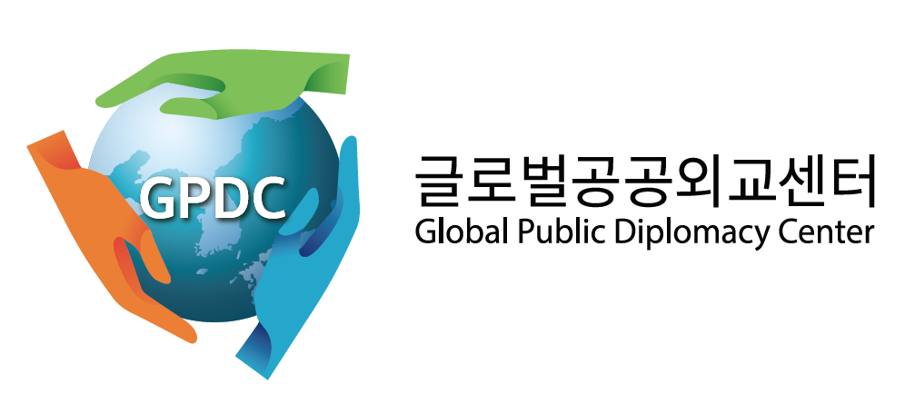
2020 Korean Public Diplomacy Paper Contest
Entry Form

Contact Information:
Name:
Email Address:
Secondary e-mail address:

I here certify that I am submitting original work.
NAME | UNIVERSITY | LEVEL OF STUDY | NATIONALITY | SIGNATURE
- Undergraduate student
- Master’s student
- PhD student
By signing the above, contestants confirm that they have read and will follow the guidelines of this contest. Any contestant violating these guidelines will be disqualified.

Title of the Submission:

Contest Entry Checklist
- I have read the contest guidelines
- My submission (two copies of my written work) is attached to this entry form.
Please submit your work and a completed entry form to publicdiplomacyGPDC@gmail.com by 30 September 30, 2020.

